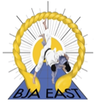 | BRITISH JUDO ASSOCIATION  East Anglian Fours  April 28^{th,} 2024  Entry Form

Club Name

Contact Name

Telephone Number

Email Address

Payment Reference | For all BACS payments, please confirm payment reference used below

Name | M/F | Weight | Age | Grade | Group

